*I have completed bachelor degree in computer engineering hope to be benefit to my country and people in designing a web pages also mobile applications .*

# EDUCATION

*http://linkedin.com/in/ali-zreik-376ba3226*

*PROFILE*

***ALI ZREIK***

*Computer engineering*



[*al khiam*](http://linkedin.com/in/ali-zreik-376ba3226)

*marjeoun*



*18.10.1999*



*96103936759*

*alizreik1810@gmail.com*

*SOCIAL MEDIA*

ϩ



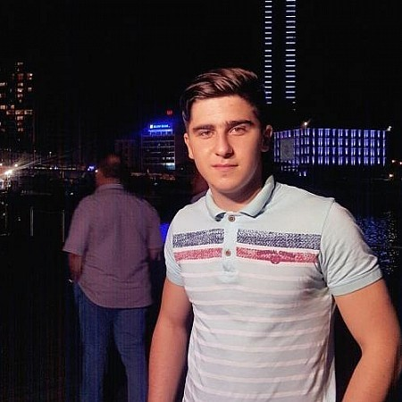

*Communicative*

*Decision Making*

*3*

*years in home decoration*



*Arabic*

*English*

*pvc & gypsum*

# HOBBY PROJECTS

*SKILLS*

*PERSONALITY*

*SOFTWARE SKILLS*

*LANGUAGES*

***lebanese international university***

*bachelor in computer engineering*

***10.2017***

***-***

***09.2021***

*Good communication - written and oral skills*

*team work , delegation, Goal Setting, Group Leadership*

*java language moderate*

*html css javascript beginner*

*android studio*



*Microsoft Word*



*netbeans*



*hunting,gym Fitness mobile application*

*.app allow you to calculate bmi scale*

*.show your workouts*

*.*

*Web application*

*design a web page for buying cars*